**Chapter 6: Stoichiometry**

**All Lectures Uploaded on YouTube:**

[**https://tinyurl.com/fkm9-chemistry**](https://tinyurl.com/fkm9-chemistry)

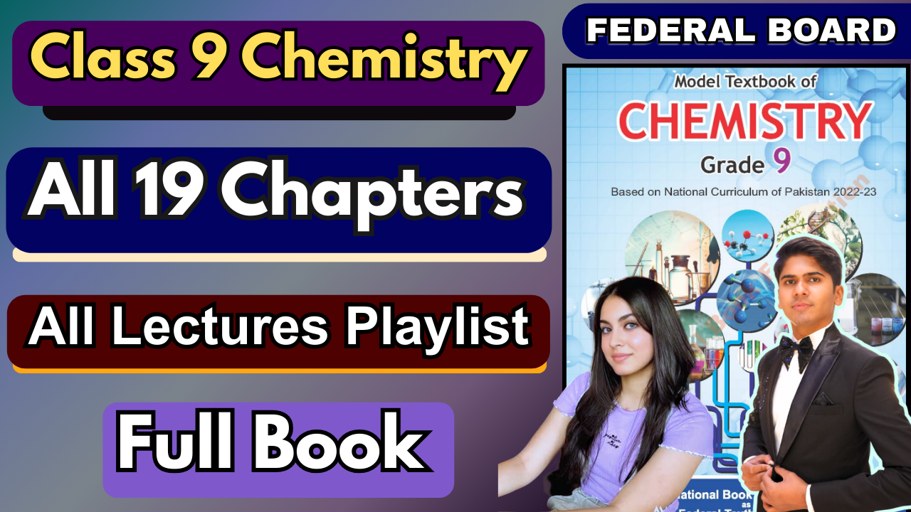

**Introduction: What is Matter Made Of?**

∙ Scientists have always wondered what makes up everything around us (wood, rocks, living things).

∙ In the 19th century, John Dalton proposed an **atomic theory**, which says that everything is made of tiny particles called **atoms**.

∙ This chapter will teach you the basic language and concepts to understand matter, which will be very helpful for future studies.

**6.1. Empirical Formula and Molecular Formula**

A chemical formula tells you which elements are in a compound and the number of their atoms. There are two main types:

**6.1.1. Empirical Formula**

**What it is:** The *simplest whole number ratio* of atoms in a compound.

**Think of it like:** A recipe reduced to its simplest form (e.g., a 2:4 ratio simplifies to 1:2). **Examples:**

o **Hydrogen Peroxide:** The actual molecule is H₂O₂, but the simplest ratio of H to O is 1:1. So, its empirical formula is **HO**.

o **Glucose:** The actual molecule is C₆H₁₂O₆. The simplest ratio of C:H:O is 1:2:1 (divide all by 6). So, its empirical formula is **CH₂O**.

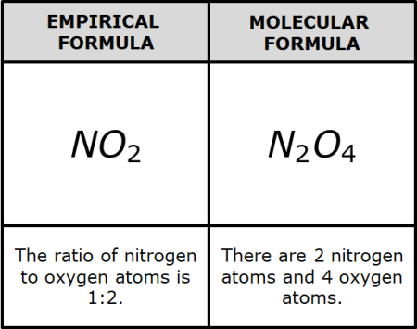

**6.1.2. Molecular Formula**

**What it is:** Shows the *actual* number of each type of atom in a single molecule of the compound. **Think of it like:** The exact, detailed recipe.

**Examples:**

o **Hydrogen Peroxide:** The molecular formula is **H₂O₂** (2 hydrogen atoms and 2 oxygen atoms).

o **Glucose:** The molecular formula is **C₆H₁₂O₆** (6 carbon, 12 hydrogen, and 6 oxygen atoms).

o **Benzene:** The molecular formula is **C₆H₆**. Since the ratio of C to H is 1:1, its empirical formula is **CH**.

**Key Relationship:**

∙ The molecular formula is often a **multiple** of the empirical formula.

∙ For example, for glucose: (CH₂O) x 6 = C₆H₁₂O₆.

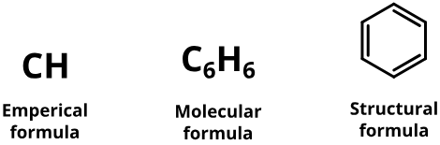

**When are they the same?**

For many simple compounds, the empirical formula *is* the molecular formula because the ratio cannot be simplified further.

∙ **Water (H₂O):** The H:O ratio is 2:1, which is already the simplest.

∙ **Carbon Dioxide (CO₂):** The C:O ratio is 1:2, which is already the simplest. ∙ Others: Ammonia (NH₃), Methane (CH₄), Sulphur dioxide (SO₂).

**6.2. Molecular Mass and Formula Mass**

**What it is:** The mass of a molecule. It's the sum of the atomic masses of all the atoms in its **molecular formula**.

**How to calculate it:**

1. Look at the molecular formula.

2. Multiply the atomic mass of each element by the number of its atoms in the molecule. 3. Add them all together.

∙ **The unit is the atomic mass unit (amu)**.

**Example: Calculating the Molecular Mass of Water (H₂O)**

1. The formula is H₂O. So, it has **2 Hydrogen atoms** and **1 Oxygen atom**.

2. Atomic mass of Hydrogen (H) ≈ 1.008 amu 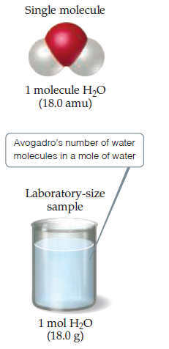

Atomic mass of Oxygen (O) = 16.00 amu

3. Calculation:

= (2 × 1.008 amu) + (1 × 16.00 amu)

= 2.016 amu + 16.00 amu

= **18.016 amu**

So, one molecule of water has a mass of about 18.016 amu.

**Formula Mass (For Ionic Compounds)**

**Molecular Mass** is the sum of atomic masses in a *molecule*. It's used for **molecular compounds** (like water H₂O or glucose C₆H₁₂O₆).

**Formula Mass** is used for **ionic compounds** (like table salt NaCl).

**Why the difference?** Ionic compounds (e.g., NaCl, MgO) don't exist as separate molecules. Instead, they form a giant 3D crystal lattice of positively charged ions (cations) and negatively charged ions (anions).

**Formula Unit:** We represent an ionic compound by its **formula unit**, which shows the simplest ratio of ions in the compound. For NaCl, the ratio of Na⁺ to Cl⁻ ions is 1:1.

*The* ***Formula Mass*** *is the sum of the atomic masses of all the atoms in a compound's* ***formula unit****.*

**Calculation:** It's calculated the same way as molecular mass!

o *Example:* Formula mass of NaCl = Atomic mass of Na (23 amu) + Atomic mass of Cl (35.5 amu) = **58.5 amu**.

**6.3. Naming and Writing Formulas for Binary Ionic Compounds**

*A* ***binary ionic compound*** *is made from a metal (which forms a positive cation) and a non-metal (which forms a negative anion).*

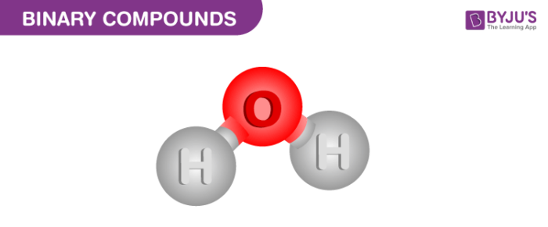

**a) How to NAME them:**

1. **First,** write the name of the **metal cation** (exactly as the element's name). 2. **Second,** write the name of the **non-metal anion**, but change the ending to **"-ide"**.

o *Examples:*

NaCl: Sodium Chlor**ine** → Sodium Chlor**ide**

MgO: Magnesium Ox**ygen** → Magnesium Ox**ide**

AlN: Aluminium Nitro**gen** → Aluminium Nitr**ide** 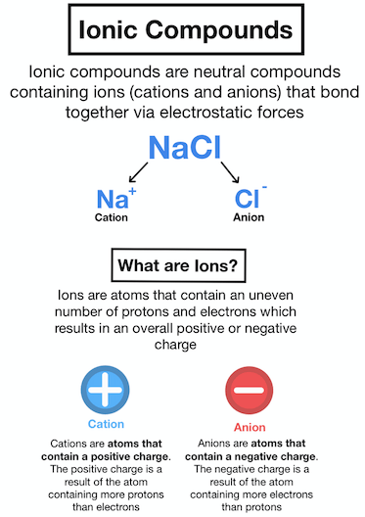

**b) How to WRITE their formulas (The Criss-Cross Method):**

**Step 1:** Write the symbols for the cation and anion **with their charges**.

o *Example for Aluminium Oxide:* Al³⁺ and O²⁻

**Step 2: Criss-Cross** the charges to become the subscripts for the other ion. Use the smallest whole numbers.

o The '3' from Al³⁺ becomes the subscript for O.

o The '2' from O²⁻ becomes the subscript for Al.

o This gives: Al₂O₃

**Step 3: Check for Neutrality:** The total positive charge must equal the total negative charge. o Al₂O₃: (2 Al × +3) = +6 and (3 O × -2) = -6. The compound is neutral ✅

**Important:** If the subscripts have a common factor, simplify them. For example, Mg₂O₂ simplifies to MgO.

**6.4. The Mole & Avogadro's Number**

**The Problem:** Atoms and molecules are extremely small and tiny. We can't count them individually. We need a practical "counting unit" for the particle world.

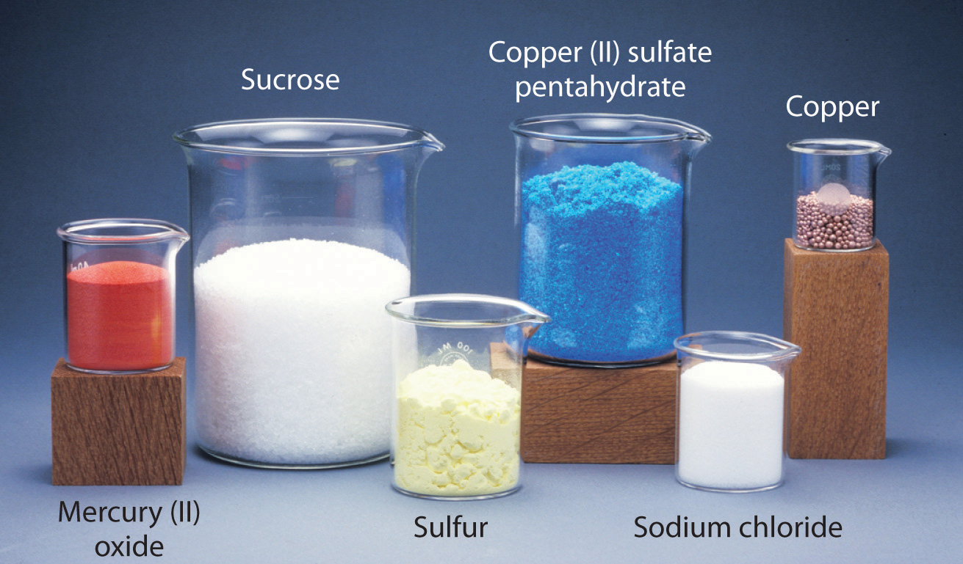

**The Solution:** The **Mole (mol)**. Just like we use...

o A **dozen** to count 12 things (eggs, oranges),

o A **ream** to count 500 things (papers),

o ...Chemists use a **mole** to count a very, very large number of particles.

**Avogadro's Number (Nₐ):** One mole of a substance contains **6.022×1023** representative particles. This is a HUGE number: 602,200,000,000,000,000,000,000.

**Examples:**

▪ 1 mole of Carbon atoms = 6.022×1023 C atoms

▪ 1 mole of Sulphur atoms = 6.022×1023 S atoms

▪ 1 mole of Water molecules = 6.022×1023 H₂O molecules

▪ 1 mole of NaCl formula units = 6.022×1023 NaCl formula units

**6.5. Molar Mass & Chemical Calculations**

**1. Molar Mass: The Grand Summary**

The **mass of one mole** of any substance is called its **Molar Mass**. Its unit is grams per mole (g/mol). Think of it as the "weight" of a chemical "dozen" (where a dozen is 6.022×1023 particles).

This single concept has three specific names depending on what you're measuring: **a) Gram Atomic Mass (For Elements)**

**What it is:** The atomic mass from the periodic table, expressed in **grams**. **It contains: 1 mole of atoms** (6.022×1023 atoms) of an element.

**Examples:**

o Carbon (C): Atomic mass = 12 amu → **Gram Atomic Mass = 12 g/mol** o Sodium (Na): Atomic mass = 23 amu → **Gram Atomic Mass = 23 g/mol** o This means **12 grams of Carbon** contains exactly 6.022×10236.022×1023 carbon atoms.

**b) Gram Molecular Mass (For Molecules)**

The molecular mass of a compound, expressed in **grams**.

**It contains: 1 mole of molecules** (6.022×1023molecules).

**Examples:**

o Water (H₂O): Molecular mass = 18.016 amu → **Gram Molecular Mass = 18.016 g/mol** o Glucose (C₆H₁₂O₆): Molecular mass = 180.096 amu → **Gram Molecular Mass = 180.096 g/mol**

o This means **18.016 grams of Water** contains exactly 6.022×10236.022×1023 H₂O molecules.

**c) Gram Formula Mass (For Ionic Compounds)**

**What it is:** The formula mass of an ionic compound, expressed in **grams**. **It contains: 1 mole of formula units** (6.022×10236.022×1023 formula units). **Examples:**

o Sodium Chloride (NaCl): Formula mass = 58.5 amu → **Gram Formula Mass = 58.5 g/mol**

o Potassium Chloride (KCl): Formula mass = 74.5 amu → **Gram Formula Mass = 74.5 g/mol**

o This means **58.5 grams of NaCl** contains exactly 6.022×10236.022×1023 NaCl formula units.

**The Unified Concept: Molar Mass**

∙ All three terms (**Gram Atomic Mass, Gram Molecular Mass, and Gram Formula Mass**) are collectively known as **Molar Mass**.

∙ **Simple Definition of a Mole:** A mole is the **atomic mass, molecular mass, or formula mass expressed in grams**.

**Introduction to Chemical Calculations**

This is where everything comes together. The concepts of the mole, Avogadro's number, and molar mass form a powerful toolkit for solving chemical problems.

You can use these relationships as conversion factors:

**Connecting Mass to Moles:**

o **Moles = Mass (g) ÷ Molar Mass (g/mol)**

**Connecting Moles to Number of Particles:**

o **Number of Particles = Moles × (6.022×10236.022×1023 particles/mol)**

**Connecting Mass directly to Number of Particles:**

o **Number of Particles = [Mass (g) ÷ Molar Mass (g/mol)] × (6.022×1023) Mole-Mass Calculations & Chemical Equations**

**Part 1: Mole-Mass Calculations**

This is the practical application of the mole concept. We use molar mass as a conversion factor. **The Core Formula:**

∙ **Mass (g) = Moles (mol) × Molar Mass (g/mol)**

∙ This formula lets you find the mass if you know the number of moles, or find the number of moles if you know the mass.

**Type 1: Calculating Molar Mass**

**Rule:**

∙ For a **metal** (like Na, Cu, K), the molar mass is simply its **atomic mass in grams** (Gram Atomic Mass).

∙ For a **non-metal that exists as a molecule** (like N₂, O₂, I₂), the molar mass is its **molecular mass in grams** (Gram Molecular Mass).

∙ For a **compound**, the molar mass is its **molecular or formula mass in grams**.

**Example 6.3: Calculating Molar Mass**

a) **Sodium (Na):** It's a metal.

Molar Mass = **23 g/mol**

b) **Nitrogen (N):** It exists as diatomic molecules (N₂).

Molecular mass of N₂ = 14 × 2 = **28 amu**

Molar Mass = **28 g/mol**

c) **Sucrose (C₁₂H₂₂O₁₁):** It's a molecular compound.

Molecular mass = (12×12) + (1×22) + (16×11) = 144 + 22 + 176 = **342 amu** Molar Mass = **342 g/mol**

**Type 2: Calculating the Mass from Moles** This uses the core formula directly: **Mass = Moles × Molar Mass Example 6.4: Mass of Ozone (O₃)**

**Given:** Moles of O₃ = 9.05 mol

**Step 1: Find Molar Mass of O₃**

o Molar Mass = 16 × 3 = **48 g/mol**

**Step 2: Apply Formula**

o Mass = Moles × Molar Mass

o Mass = 9.05 mol × 48 g/mol

o Mass = **434.4 g**

**Answer:** The mass of 9.05 moles of ozone is **434.4 grams**. **Example 6.5: Mass of Carbon Dioxide (CO₂)**

**Given:** Moles of CO₂ = 0.25 mol

**Step 1: Find Molar Mass of CO₂**

o Molar Mass = 12 + (16 × 2) = **44 g/mol**

**Step 2: Apply Formula**

o Mass = 0.25 mol × 44 g/mol

o Mass = **11 g**

∙ **Answer:** The mass of 0.25 moles of CO₂ is **11 grams**.

**6.6. Chemical Equations and Balancing**

A chemical equation is like a recipe for a chemical reaction. It shows what you start with and what you end up with.

**Parts of a Chemical Equation:**

∙ **Reactants:** The starting substances. They are written on the **left** side.

∙ **Products:** The new substances formed. They are written on the **right** side. ∙ **Arrow (→):** Means "yields" or "produces" and shows the direction of the reaction. ∙

**Steps to Write a Chemical Equation:**

**Step 1: Write the Word Equation**

∙ Identify the reactants and products.

∙ *Example (Burning Coal):* Coal + Oxygen → Carbon dioxide

**Step 2: Write the Skeleton Equation with States**

∙ Replace the names with correct chemical formulas.

∙ Add physical states in parentheses: (s)=solid, (l)=liquid, (g)=gas, (aq)=aqueous (dissolved in water).

∙ *Example (Burning Coal):*

C(s) + O₂(g) → CO₂(g)

∙ **Important:** This initial equation is often *unbalanced* (the number of atoms on the left doesn't equal the number on the right).

**Step 3: Balance the Equation!**

**Law of Conservation of Mass:** Matter cannot be created or destroyed. The number of each type of atom must be the same on both sides.

You balance by placing numbers (**coefficients**) in front of the formulas. **Never change the subscripts inside the formulas!**

*Example (Burning Coal):*

*Skeleton:* C(s) + O₂(g) → CO₂(g)

*Check Atoms:* Left: 1 C, 2 O Right: 1 C, 2 O

It's already balanced!

**Balancing Equations, Ionic Equations, and Formulas**

**Balancing Chemical Equations**

**The Golden Rule: Law of Conservation of Mass**

∙ Atoms cannot be created or destroyed in a chemical reaction.

∙ Therefore, you must have the **same number of each type of atom** on the **reactant side** (left) and the **product side** (right).

A **balanced chemical equation** is one where this rule is followed.

**How to Balance an Equation: A Step-by-Step Guide**

∙ **Coefficients:** Large numbers you place *in front* of a chemical formula. This multiplies every atom in that formula. (e.g., 2H₂O means 2 molecules of water, totaling 4 H atoms and 2 O atoms).

∙ **NEVER change the subscripts** (the small numbers within the formula). This would change the identity of the compound itself!

**Ionic Equations**

**Steps to Write an Ionic Equation:**

**Step 1: Write the Balanced Molecular Equation**

∙ HCl(aq) + NaOH(aq) → NaCl(aq) + H₂O(l)

**Step 2: Write the Complete Ionic Equation**

Split all soluble, ionic compounds (those with (aq)) into their individual ions. **Note:** Keep non-dissociating substances like liquids (l), gases (g), and solids (s) together. **Complete Ionic Equation:**

o **H⁺(aq) + Cl⁻(aq) + Na⁺(aq) + OH⁻(aq) → Na⁺(aq) + Cl⁻(aq) + H₂O(l) Step 3: Identify and Remove Spectator Ions**

**Spectator Ions:** Ions that appear unchanged on both sides of the equation. They are present but do not participate in the actual chemical change.

In this equation: **Na⁺(aq)** and **Cl⁻(aq)** are spectator ions.

**Step 4: Write the Net Ionic Equation**

This shows only the particles that actually react.

**Net Ionic Equation: H⁺(aq) + OH⁻(aq) → H₂O(l)**

This reveals the true essence of the reaction: an acid and a base combining to form water.

**6.7. Molecular Formula vs. Structural Formula**

**Molecular Formula:** Shows the **type and number** of atoms in a single molecule of a compound.

o *Example:* C₄H₁₀

**Structural Formula:** Shows **how the atoms are connected and bonded** to each other. o *Example:* CH₃-CH₂-CH₂-CH₃ (for n-Butane)

**How to Write a Molecular Formula from a Structural Formula Example: For CH₃-CH₂-CH₂-OH**

**Identify the Elements:** Carbon (C), Hydrogen (H), Oxygen (O).

**Count the Atoms:**

**Carbon (C):** There are 3 C atoms (one in each CH₃ and CH₂ group).

**Hydrogen (H):** Let's count carefully:

▪ CH₃- has 3 H

▪ -CH₂- has 2 H

▪ -CH₂- has 2 H

▪ The -OH has 1 H

**Total H = 3 + 2 + 2 + 1 = 8**

**Oxygen (O):** There is 1 O atom (in the -OH group).

**Write the Formula:** Write the symbols and the counts as subscripts.

o **Molecular Formula: C₃H₈O**

1. **Balance Equations:** Use coefficients to make atom counts equal on both sides. Never change subscripts.

2. **Write Ionic Equations:** Split (aq) compounds into ions, cancel spectators, and write the net reaction.

3. **Find Molecular Formula from Structure:** Identify all atoms and count them carefully to write the correct formula.

